Introduction to Unity:

Unity is a cross-platform game engine initially released by Unity Technologies, in 2005. The focus of Unity lies in the development of both 2D and 3D games and interactive content. Unity now supports over 20 different target platforms for deploying, while its most popular platforms are the PC, Android and iOS systems.

Creating a Project:

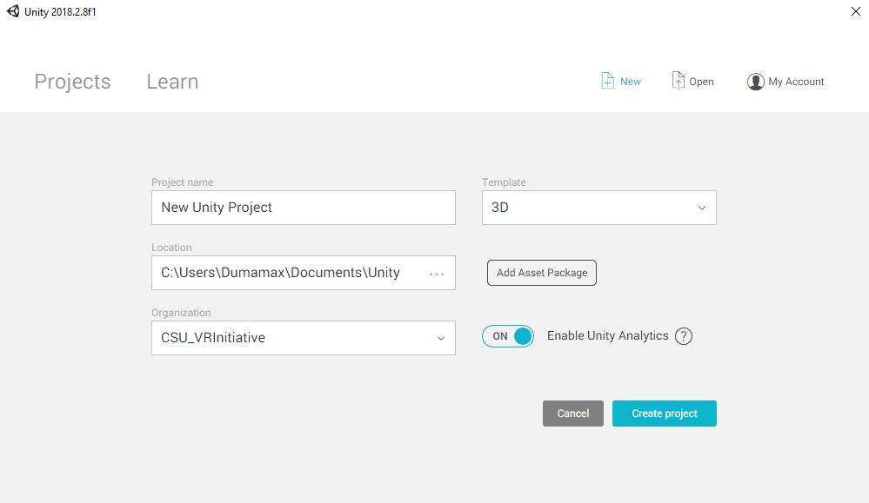

Interface:

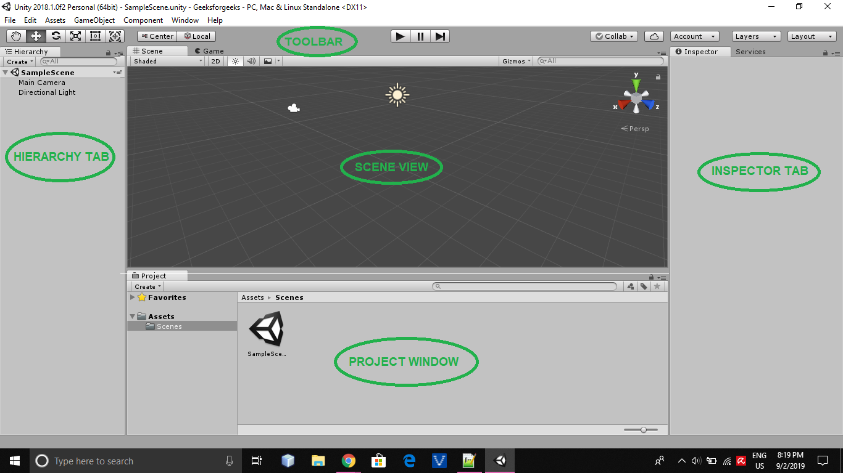

Hierarchy:

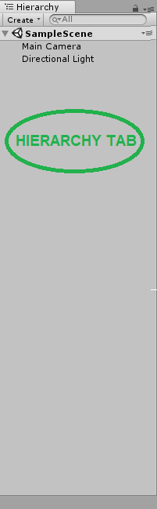

Create a Cube:

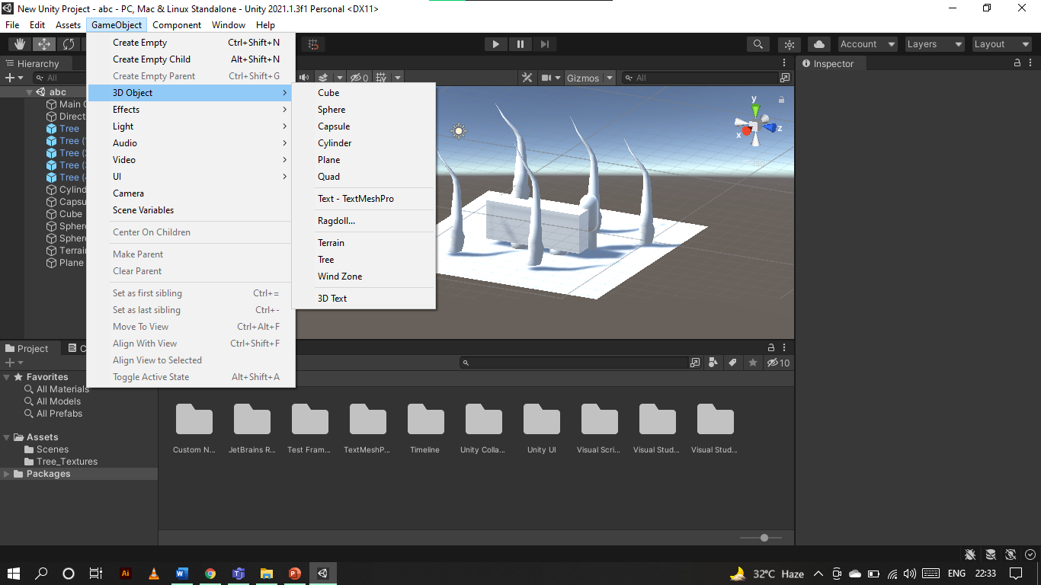

Scene/Game View:

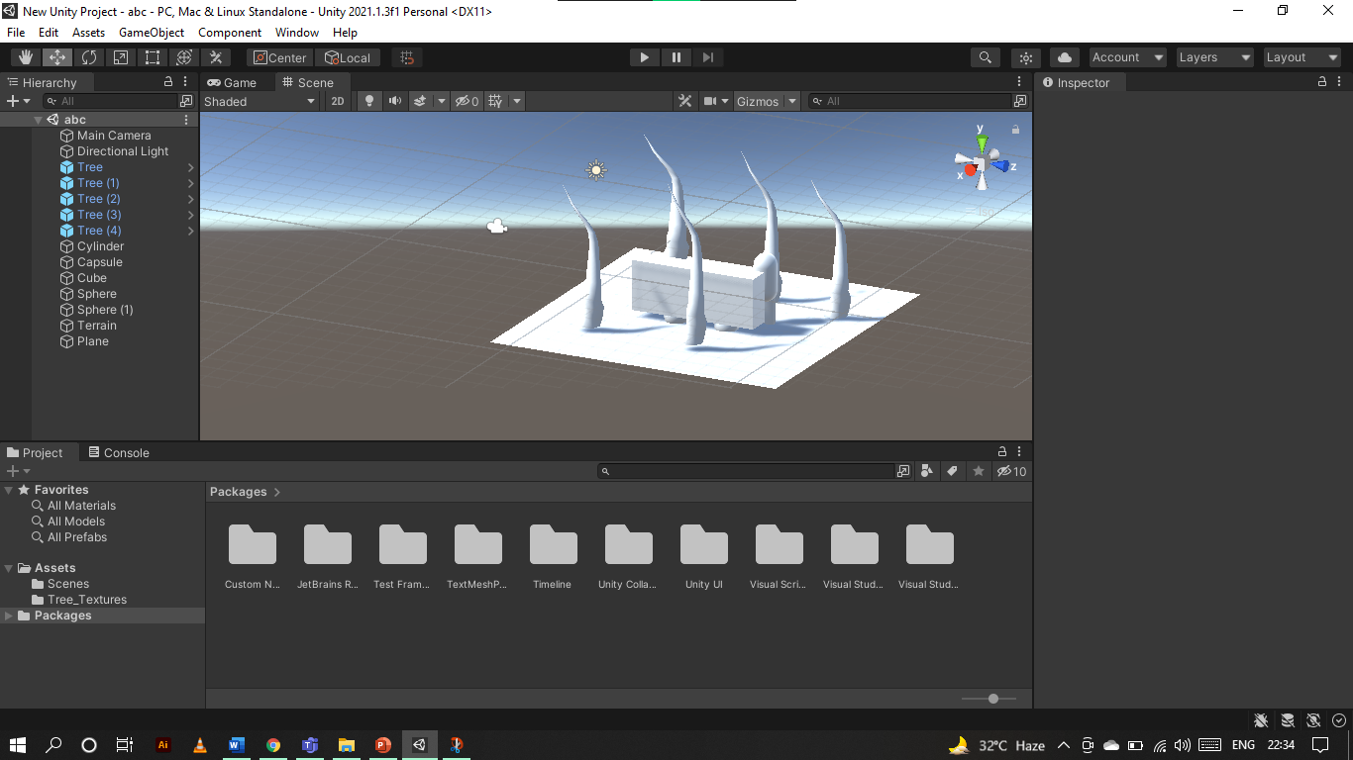

Navigating Scene View:

1. Hand Tool: Click and drag to move scene and navigate world
2. Move Tool: Move objects within the world (X, Y, Z)
3. Rotate Tool: Rotate objects along the X, Y, or Z axis
4. Scale Tool: Scale object’s size either along an axis, or overall
5. Rect Tool: Mainly used for 2D games and UI elements
6. Universal Tool: Has functionality to move, rotate, and scale



Inspector:

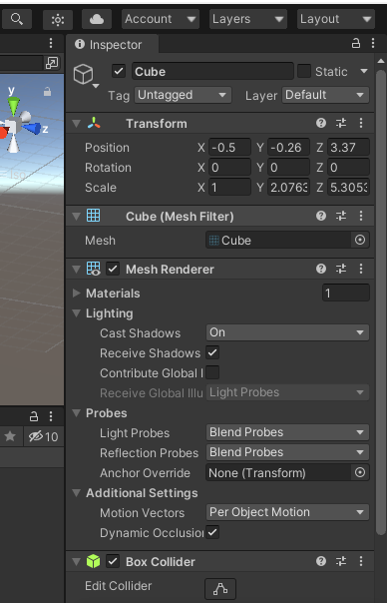

Project Window:

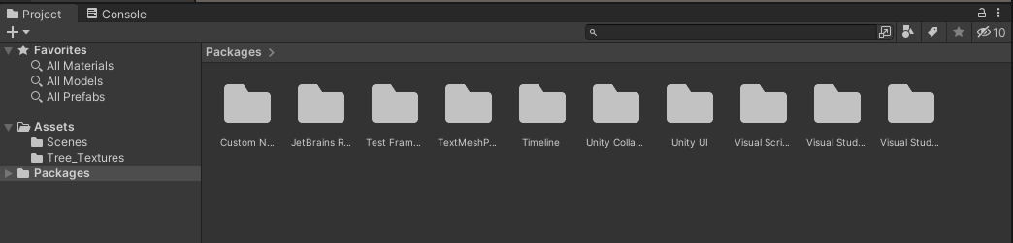

Adding Asset Store as a Window:

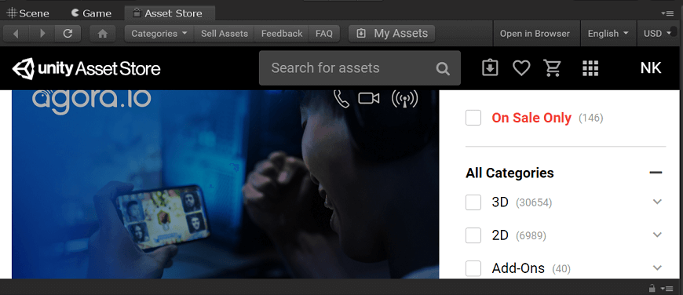

Tank Demo:

So now I will start with a demo example

I won’t step through this example, as you can just do this by following this or a more pertinent demo for the projects you wish to create

What I will do is build off of this demo, showing some of the features I have found most helpful for bringing my game development to a higher level

This might be a little more advanced, but I don’t want to waste time going over the beginner content when it is so well documented already in the demos.

I want to show something a bit more unique

General Script Structure:

Some Used Object Components: